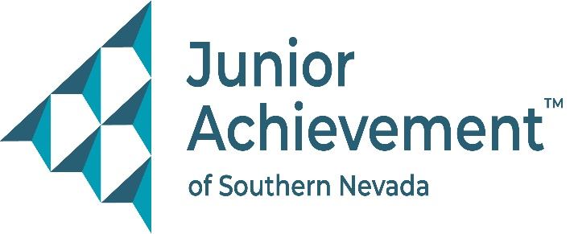
Date
FOR IMMEDIATE RELEASE:

Junior Achievement of Southern Nevada Welcomes John Starkey of UNLV to Board of Directors


LAS VEGAS – Junior Achievement of Southern Nevada (JASN) is proud to announce the appointment of John J. Starkey, associate director of the Kerestesi Center for Insurance and Risk Management at the University of Nevada, Las Vegas (UNLV), to its board of directors. A longtime champion of student success and civic engagement, Starkey brings a wealth of experience in higher education leadership, academic program development, and industry collaboration to support the nonprofit financial literacy organization’s mission of preparing young people for economic success.
In his current role, Starkey leads the strategic direction of the Kerestesi Center, including academic program creation, industry engagement, financial oversight, and student scholarship support. He was instrumental in designing UNLV’s Bachelor of Science in Business Administration major in Insurance and Risk Management, and he continues to guide student recruitment and curriculum development. His leadership also extends to planning industry events, managing donor relations, and mentoring student leaders.
Starkey’s journey with UNLV began in 2005 as a student employee, eventually earning his Bachelor of Science in Business Administration and a Master of Education in Educational Leadership. Since 2012, he has served in multiple professional roles at UNLV, focused on advising, student support, and academic advancement.
“John’s dedication to student empowerment and his deep roots in the education and insurance sectors make him a tremendous asset to our board,” said Michelle Jackson, JASN president and CEO. “His leadership has already made a measurable impact through our partnership with UNLV, and we are thrilled to welcome him in this new capacity.”
Starkey’s relationship with JASN began in 2018, sparking a collaborative effort that brought Junior Achievement programming into UNLV classrooms, launched scholarships, and connected K-12 students with college mentors. That work earned him recognition with the UNLV’s Faculty/Staff Community Outreach Award and helped strengthen JASN’s connection to the local community.
“What inspires me most about Junior Achievement is how strongly it aligns with my belief in the life-changing power of financial literacy, career education, and entrepreneurship,” said Starkey. “I’ve seen firsthand how its programs equip students with the confidence and knowledge to build a better future. I’m honored to join the board and support this mission.”
Born and raised in West Virginia, Starkey has proudly called Las Vegas home for over two decades. Outside of his professional life, he is a passionate advocate for mentoring, civic engagement, and student leadership. He embodies strength and perseverance, values that mirror Junior Achievement’s mission to empower young people to thrive.
About Junior Achievement of Southern Nevada
Founded locally in 1996, Junior Achievement of Southern Nevada, Inc. is dedicated to providing financial education to K-12 students and young adults with a curriculum including wants vs. needs, budget management to economic principals, workforce skills, credit and entrepreneurship. The completion of the new 40,000-square-foot Junior Achievement of Southern Nevada Inspiration Center will allow the nonprofit organization to impact more than 60,000 local youth. It is now the permanent site for capstone programs, Betty’s JA BizTown and JA Finance Park. Junior Achievement of Southern Nevada’s financial literacy mission is accomplished with the support of 285 businesses and 6,800 business role models, who help youth learn about the “business of life,” by helping bridge the gap between what youth learn in school and the real world. For more information visit https://jasnv.org/ and follow on Instagram and Facebook.

# # #

MEDIA CONTACT:
Nancy Katz, Purdue Marion & Associates, 702-349-0063 or nancy@purduemarion.com

